Evidencia de Pruebas Unitarias - Servicio T24FN1008
Fecha: 2/13/2026
Responsable: Joel Stalin Martinez Espinal
Versión: 1.0

Caso de Prueba 1: Consulta de Transacciones de Depósito
- Objetivo: Validar que el servicio devuelve correctamente la lista de transacciones para una cuenta de depósito dentro de un rango de fechas específico.
- Datos de Entrada:
Campo | Valor de Prueba
functionCode | "MSG010010D"
idSol | "455648540000000006000000"
date | "20260213"
time | "105612"
user | "CUSTOMER "
accountId | "1860280"
startDate | "20240801"
endDate | "20251030"
- Resultado Esperado: Se espera una respuesta en formato JSON con un header indicando una operación exitosa (sin código de error) y un body que contenga un array con los objetos de las transacciones encontradas para la cuenta especificada.
Evidencia:
- Mensaje de Entrada (Input):
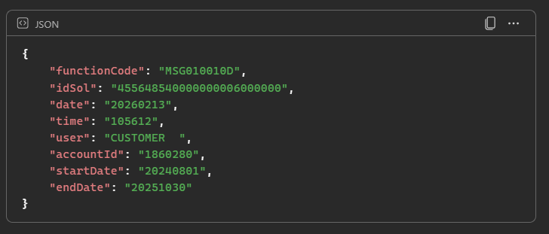
- Mensaje de Salia (Output):
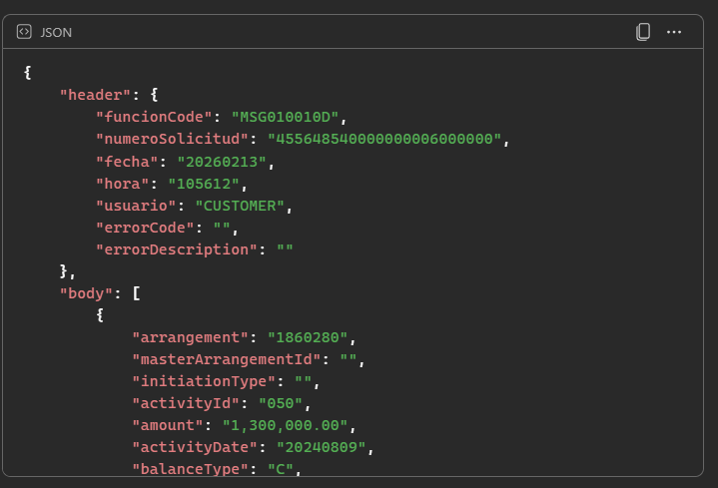
{
"header": {
"funcionCode": "MSG010010D",
"numeroSolicitud": "455648540000000006000000",
"fecha": "20260213",
"hora": "105612",
"usuario": "CUSTOMER",
"errorCode": "",
"errorDescription": ""
},
"body": [
{
"arrangement": "1860280",
"masterArrangementId": "",
"initiationType": "",
"activityId": "050",
"amount": "1,300,000.00",
"activityDate": "20240809",
"balanceType": "C",
"description": "Venta de Deposito a",
"activityReference": " ",
"activityType": " ",
"account": "1860280",
"status": " "
},
{
"arrangement": "1860280",
"masterArrangementId": "",
"initiationType": "",
"activityId": "060",
"amount": ".00",
"activityDate": "20240901",
"balanceType": "D",
"description": "Intereses Devengados",
"activityReference": " ",
"activityType": " ",
"account": "1860280",
"status": " "
},
{
"arrangement": "1860280",
"masterArrangementId": "",
"initiationType": "",
"activityId": "060",
"amount": ".00",
"activityDate": "20240902",
"balanceType": "C",
"description": "Retiro de Intereses",
"activityReference": " ",
"activityType": " ",
"account": "1860280",
"status": " "
},
{
"arrangement": "1860280",
"masterArrangementId": "",
"initiationType": "",
"activityId": "050",
"amount": "4,734.13",
"activityDate": "20240902",
"balanceType": "C",
"description": "Capitaliza Int.Acumu",
"activityReference": " ",
"activityType": " ",
"account": "1860280",
"status": " "
},
{
"arrangement": "1860280",
"masterArrangementId": "",
"initiationType": "",
"activityId": "060",
"amount": ".00",
"activityDate": "20241001",
"balanceType": "D",
"description": "Intereses Devengados",
"activityReference": " ",
"activityType": " ",
"account": "1860280",
"status": " "
},
{
"arrangement": "1860280",
"masterArrangementId": "",
"initiationType": "",
"activityId": "060",
"amount": ".00",
"activityDate": "20241001",
"balanceType": "C",
"description": "Retiro de Intereses",
"activityReference": " ",
"activityType": " ",
"account": "1860280",
"status": " "
},
{
"arrangement": "1860280",
"masterArrangementId": "",
"initiationType": "",
"activityId": "050",
"amount": "6,197.45",
"activityDate": "20241001",
"balanceType": "C",
"description": "Capitaliza Int.Acumu",
"activityReference": " ",
"activityType": " ",
"account": "1860280",
"status": " "
},
{
"arrangement": "1860280",
"masterArrangementId": "",
"initiationType": "",
"activityId": "060",
"amount": ".00",
"activityDate": "20241101",
"balanceType": "D",
"description": "Intereses Devengados",
"activityReference": " ",
"activityType": " ",
"account": "1860280",
"status": " "
},
{
"arrangement": "1860280",
"masterArrangementId": "",
"initiationType": "",
"activityId": "060",
"amount": ".00",
"activityDate": "20241101",
"balanceType": "C",
"description": "Retiro de Intereses",
"activityReference": " ",
"activityType": " ",
"account": "1860280",
"status": " "
},
{
"arrangement": "1860280",
"masterArrangementId": "",
"initiationType": "",
"activityId": "050",
"amount": "6,434.40",
"activityDate": "20241101",
"balanceType": "C",
"description": "Capitaliza Int.Acumu",
"activityReference": " ",
"activityType": " ",
"account": "1860280",
"status": " "
},
{
"arrangement": "1860280",
"masterArrangementId": "",
"initiationType": "",
"activityId": "060",
"amount": ".00",
"activityDate": "20241201",
"balanceType": "D",
"description": "Intereses Devengados",
"activityReference": " ",
"activityType": " ",
"account": "1860280",
"status": " "
},
{
"arrangement": "1860280",
"masterArrangementId": "",
"initiationType": "",
"activityId": "060",
"amount": ".00",
"activityDate": "20241202",
"balanceType": "C",
"description": "Retiro de Intereses",
"activityReference": " ",
"activityType": " ",
"account": "1860280",
"status": " "
},
{
"arrangement": "1860280",
"masterArrangementId": "",
"initiationType": "",
"activityId": "050",
"amount": "6,257.45",
"activityDate": "20241202",
"balanceType": "C",
"description": "Capitaliza Int.Acumu",
"activityReference": " ",
"activityType": " ",
"account": "1860280",
"status": " "
},
{
"arrangement": "1860280",
"masterArrangementId": "",
"initiationType": "",
"activityId": "060",
"amount": ".00",
"activityDate": "20250101",
"balanceType": "D",
"description": "Intereses Devengados",
"activityReference": " ",
"activityType": " ",
"account": "1860280",
"status": " "
},
{
"arrangement": "1860280",
"masterArrangementId": "",
"initiationType": "",
"activityId": "060",
"amount": ".00",
"activityDate": "20250102",
"balanceType": "C",
"description": "Retiro de Intereses",
"activityReference": " ",
"activityType": " ",
"account": "1860280",
"status": " "
},
{
"arrangement": "1860280",
"masterArrangementId": "",
"initiationType": "",
"activityId": "050",
"amount": "6,496.72",
"activityDate": "20250102",
"balanceType": "C",
"description": "Capitaliza Int.Acumu",
"activityReference": " ",
"activityType": " ",
"account": "1860280",
"status": " "
},
{
"arrangement": "1860280",
"masterArrangementId": "",
"initiationType": "",
"activityId": "060",
"amount": ".00",
"activityDate": "20250201",
"balanceType": "D",
"description": "Intereses Devengados",
"activityReference": " ",
"activityType": " ",
"account": "1860280",
"status": " "
},
{
"arrangement": "1860280",
"masterArrangementId": "",
"initiationType": "",
"activityId": "060",
"amount": ".00",
"activityDate": "20250203",
"balanceType": "C",
"description": "Retiro de Intereses",
"activityReference": " ",
"activityType": " ",
"account": "1860280",
"status": " "
},
{
"arrangement": "1860280",
"masterArrangementId": "",
"initiationType": "",
"activityId": "050",
"amount": "6,528.64",
"activityDate": "20250203",
"balanceType": "C",
"description": "Capitaliza Int.Acumu",
"activityReference": " ",
"activityType": " ",
"account": "1860280",
"status": " "
},
{
"arrangement": "1860280",
"masterArrangementId": "",
"initiationType": "",
"activityId": "060",
"amount": ".00",
"activityDate": "20250301",
"balanceType": "D",
"description": "Intereses Devengados",
"activityReference": " ",
"activityType": " ",
"account": "1860280",
"status": " "
},
{
"arrangement": "1860280",
"masterArrangementId": "",
"initiationType": "",
"activityId": "060",
"amount": ".00",
"activityDate": "20250303",
"balanceType": "C",
"description": "Retiro de Intereses",
"activityReference": " ",
"activityType": " ",
"account": "1860280",
"status": " "
},
{
"arrangement": "1860280",
"masterArrangementId": "",
"initiationType": "",
"activityId": "050",
"amount": "5,925.87",
"activityDate": "20250303",
"balanceType": "C",
"description": "Capitaliza Int.Acumu",
"activityReference": " ",
"activityType": " ",
"account": "1860280",
"status": " "
},
{
"arrangement": "1860280",
"masterArrangementId": "",
"initiationType": "",
"activityId": "060",
"amount": ".00",
"activityDate": "20250401",
"balanceType": "D",
"description": "Intereses Devengados",
"activityReference": " ",
"activityType": " ",
"account": "1860280",
"status": " "
},
{
"arrangement": "1860280",
"masterArrangementId": "",
"initiationType": "",
"activityId": "060",
"amount": ".00",
"activityDate": "20250401",
"balanceType": "C",
"description": "Retiro de Intereses",
"activityReference": " ",
"activityType": " ",
"account": "1860280",
"status": " "
},
{
"arrangement": "1860280",
"masterArrangementId": "",
"initiationType": "",
"activityId": "050",
"amount": "6,589.72",
"activityDate": "20250401",
"balanceType": "C",
"description": "Capitaliza Int.Acumu",
"activityReference": " ",
"activityType": " ",
"account": "1860280",
"status": " "
},
{
"arrangement": "1860280",
"masterArrangementId": "",
"initiationType": "",
"activityId": "060",
"amount": ".00",
"activityDate": "20250501",
"balanceType": "D",
"description": "Intereses Devengados",
"activityReference": " ",
"activityType": " ",
"account": "1860280",
"status": " "
},
{
"arrangement": "1860280",
"masterArrangementId": "",
"initiationType": "",
"activityId": "060",
"amount": ".00",
"activityDate": "20250501",
"balanceType": "C",
"description": "Retiro de Intereses",
"activityReference": " ",
"activityType": " ",
"account": "1860280",
"status": " "
},
{
"arrangement": "1860280",
"masterArrangementId": "",
"initiationType": "",
"activityId": "050",
"amount": "6,408.56",
"activityDate": "20250501",
"balanceType": "C",
"description": "Capitaliza Int.Acumu",
"activityReference": " ",
"activityType": " ",
"account": "1860280",
"status": " "
},
{
"arrangement": "1860280",
"masterArrangementId": "",
"initiationType": "",
"activityId": "060",
"amount": ".00",
"activityDate": "20250601",
"balanceType": "D",
"description": "Intereses Devengados",
"activityReference": " ",
"activityType": " ",
"account": "1860280",
"status": " "
},
{
"arrangement": "1860280",
"masterArrangementId": "",
"initiationType": "",
"activityId": "060",
"amount": ".00",
"activityDate": "20250602",
"balanceType": "C",
"description": "Retiro de Intereses",
"activityReference": " ",
"activityType": " ",
"account": "1860280",
"status": " "
},
{
"arrangement": "1860280",
"masterArrangementId": "",
"initiationType": "",
"activityId": "050",
"amount": "6,653.57",
"activityDate": "20250602",
"balanceType": "C",
"description": "Capitaliza Int.Acumu",
"activityReference": " ",
"activityType": " ",
"account": "1860280",
"status": " "
},
{
"arrangement": "1860280",
"masterArrangementId": "",
"initiationType": "",
"activityId": "060",
"amount": ".00",
"activityDate": "20250701",
"balanceType": "D",
"description": "Intereses Devengados",
"activityReference": " ",
"activityType": " ",
"account": "1860280",
"status": " "
},
{
"arrangement": "1860280",
"masterArrangementId": "",
"initiationType": "",
"activityId": "060",
"amount": ".00",
"activityDate": "20250701",
"balanceType": "C",
"description": "Retiro de Intereses",
"activityReference": " ",
"activityType": " ",
"account": "1860280",
"status": " "
},
{
"arrangement": "1860280",
"masterArrangementId": "",
"initiationType": "",
"activityId": "050",
"amount": "6,470.65",
"activityDate": "20250701",
"balanceType": "C",
"description": "Capitaliza Int.Acumu",
"activityReference": " ",
"activityType": " ",
"account": "1860280",
"status": " "
},
{
"arrangement": "1860280",
"masterArrangementId": "",
"initiationType": "",
"activityId": "060",
"amount": ".00",
"activityDate": "20250801",
"balanceType": "D",
"description": "Intereses Devengados",
"activityReference": " ",
"activityType": " ",
"account": "1860280",
"status": " "
},
{
"arrangement": "1860280",
"masterArrangementId": "",
"initiationType": "",
"activityId": "060",
"amount": ".00",
"activityDate": "20250801",
"balanceType": "C",
"description": "Retiro de Intereses",
"activityReference": " ",
"activityType": " ",
"account": "1860280",
"status": " "
},
{
"arrangement": "1860280",
"masterArrangementId": "",
"initiationType": "",
"activityId": "050",
"amount": "6,718.01",
"activityDate": "20250801",
"balanceType": "C",
"description": "Capitaliza Int.Acumu",
"activityReference": " ",
"activityType": " ",
"account": "1860280",
"status": " "
},
{
"arrangement": "1860280",
"masterArrangementId": "",
"initiationType": "",
"activityId": "060",
"amount": ".00",
"activityDate": "20250901",
"balanceType": "D",
"description": "Intereses Devengados",
"activityReference": " ",
"activityType": " ",
"account": "1860280",
"status": " "
},
{
"arrangement": "1860280",
"masterArrangementId": "",
"initiationType": "",
"activityId": "060",
"amount": ".00",
"activityDate": "20250901",
"balanceType": "C",
"description": "Retiro de Intereses",
"activityReference": " ",
"activityType": " ",
"account": "1860280",
"status": " "
},
{
"arrangement": "1860280",
"masterArrangementId": "",
"initiationType": "",
"activityId": "050",
"amount": "6,750.92",
"activityDate": "20250901",
"balanceType": "C",
"description": "Capitaliza Int.Acumu",
"activityReference": " ",
"activityType": " ",
"account": "1860280",
"status": " "
},
{
"arrangement": "1860280",
"masterArrangementId": "",
"initiationType": "",
"activityId": "060",
"amount": ".00",
"activityDate": "20251001",
"balanceType": "D",
"description": "Intereses Devengados",
"activityReference": " ",
"activityType": " ",
"account": "1860280",
"status": " "
},
{
"arrangement": "1860280",
"masterArrangementId": "",
"initiationType": "",
"activityId": "060",
"amount": ".00",
"activityDate": "20251001",
"balanceType": "C",
"description": "Retiro de Intereses",
"activityReference": " ",
"activityType": " ",
"account": "1860280",
"status": " "
},
{
"arrangement": "1860280",
"masterArrangementId": "",
"initiationType": "",
"activityId": "050",
"amount": "6,565.25",
"activityDate": "20251001",
"balanceType": "C",
"description": "Capitaliza Int.Acumu",
"activityReference": " ",
"activityType": " ",
"account": "1860280",
"status": " "
}
]
}

